**TASK 16:**

**Using MySQL, design a database whose name is IMDB.**

**Creating IMDB database with MySQL commands**

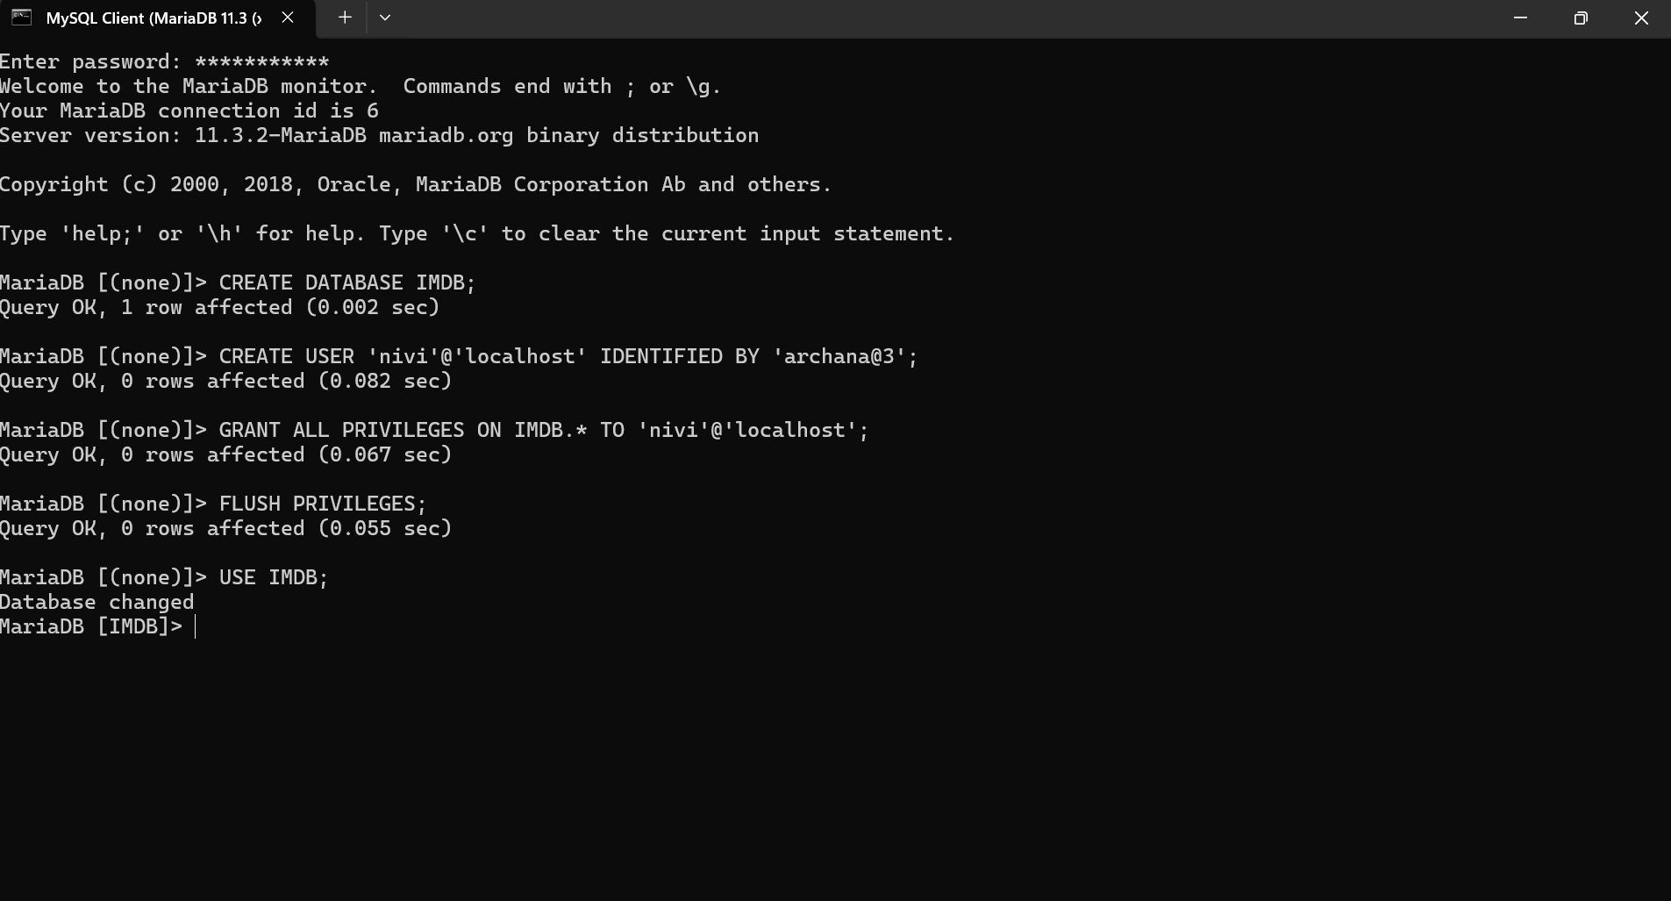

**Creating table Movies_data:**

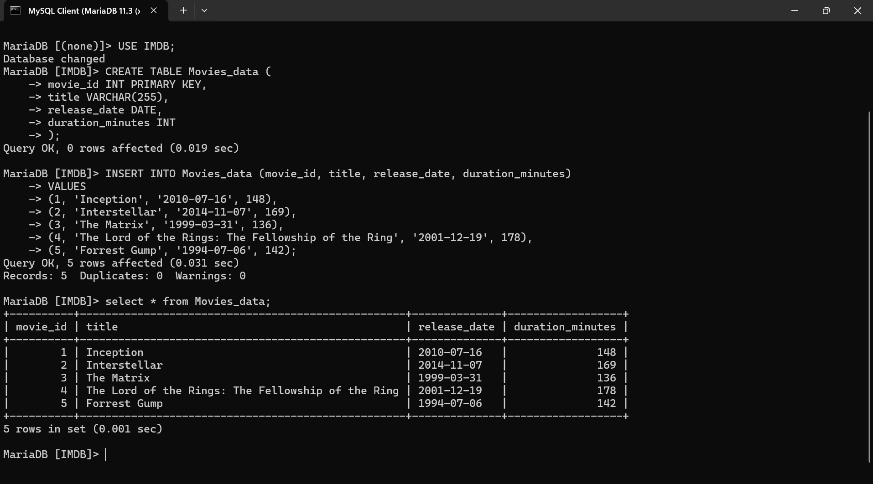

1.**Movie should have Multiple media**

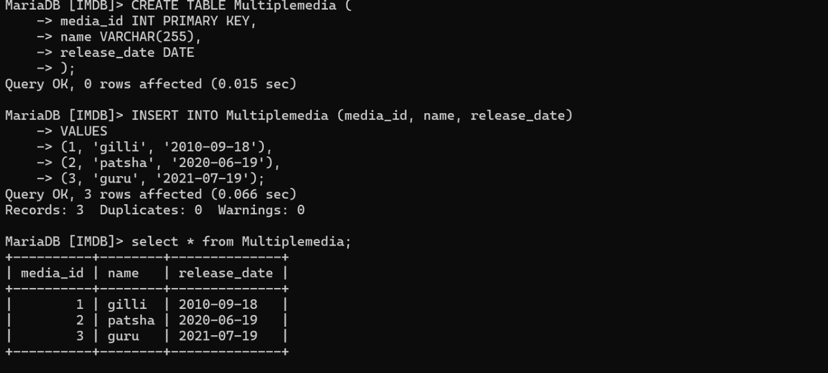

**2. Movie can belong to multiple genre:**

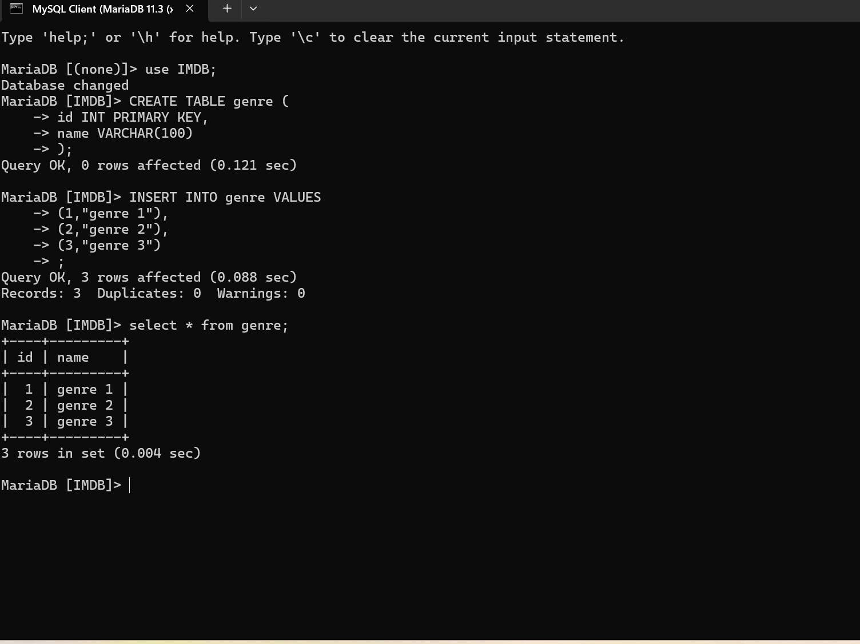

**3.Movies can have multiple reviews and reviews can belongs to a user:**

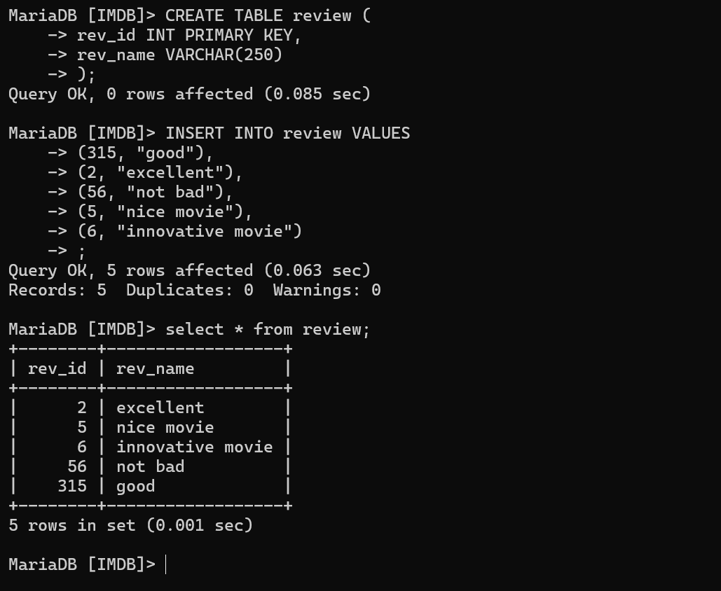

**4. Artist can have multiple skills:**

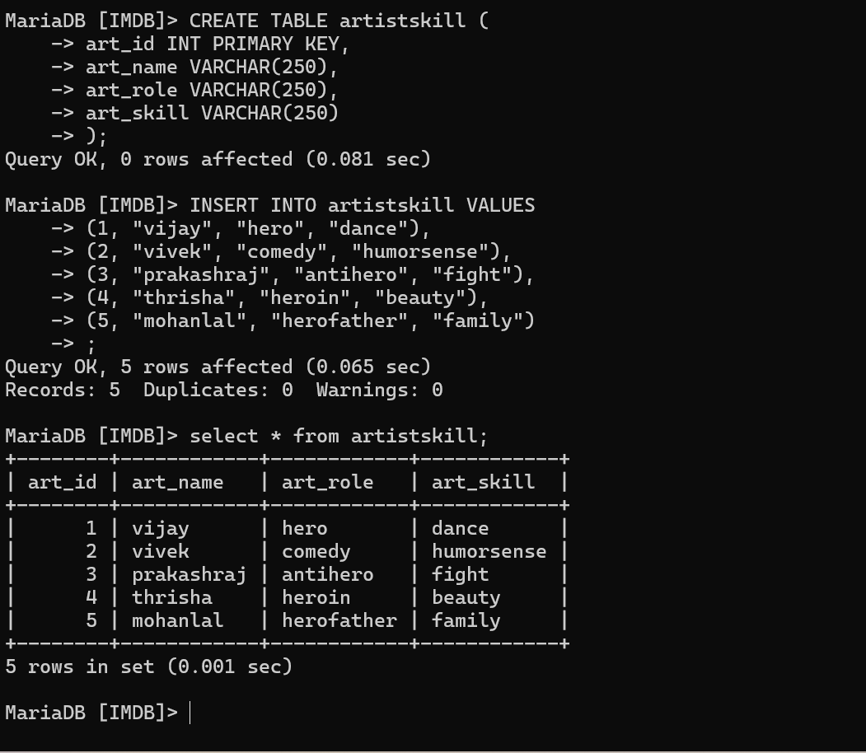

**5.Artist can have multiple role single movie:**

